**Operating System**

1. **Serial Processing OS:**

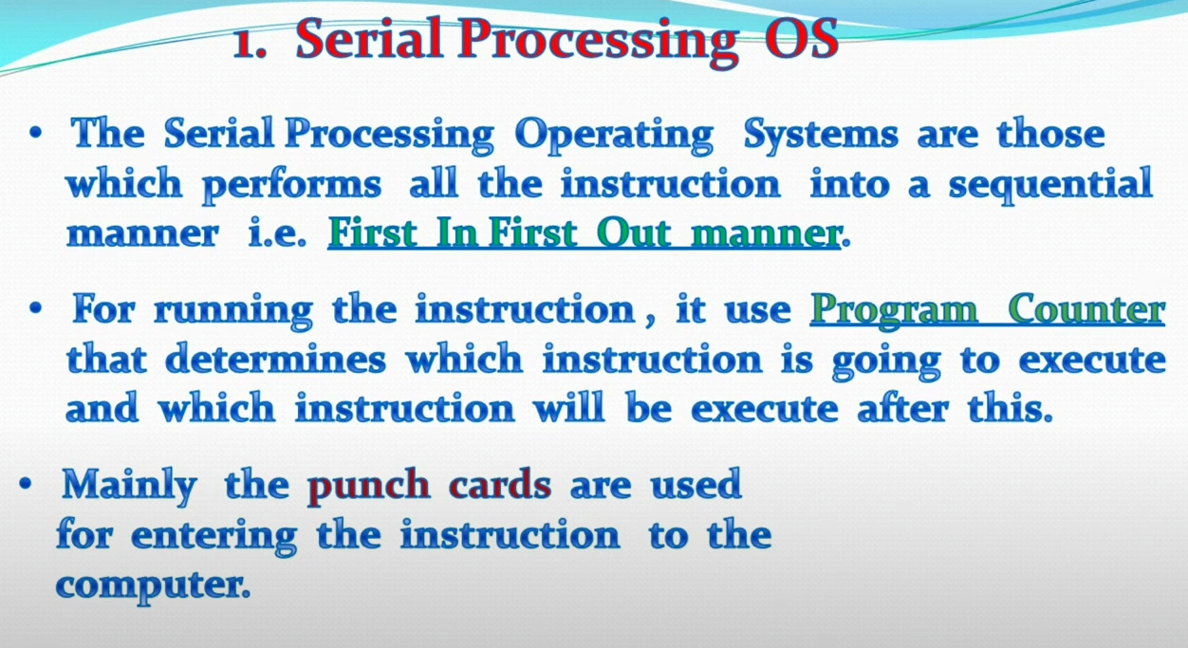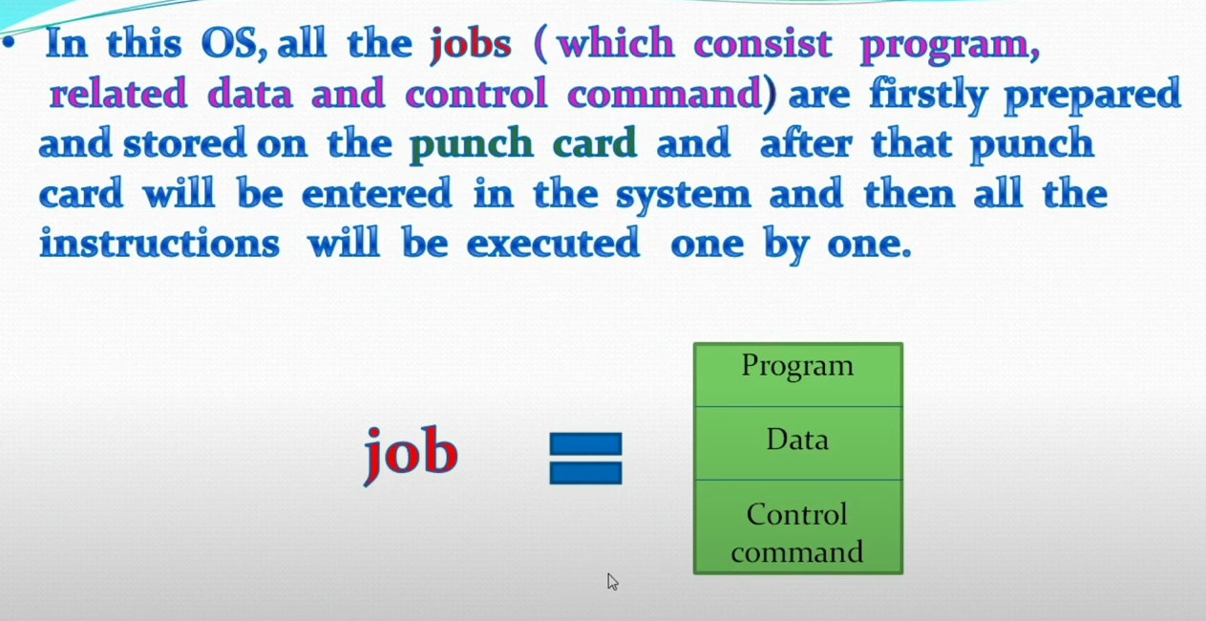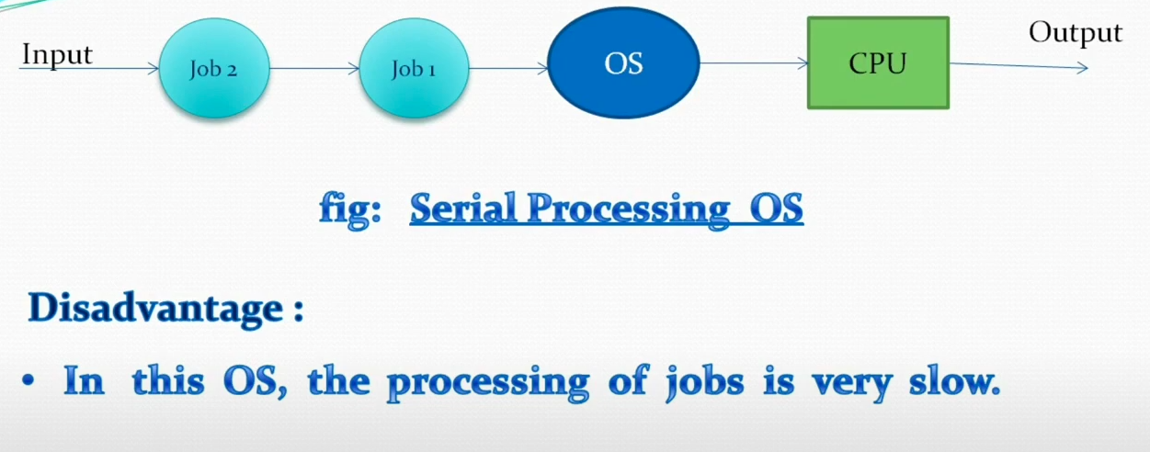

**OS Strcutures**

1. **Monolithic Structure : (unix follows this)**

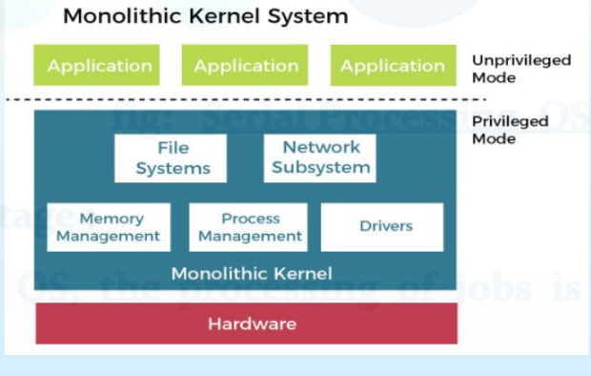

Advantages:  
1.**Fast Execution** – Since all services (like memory management, file system, and device drivers) run in kernel mode, there is minimal context switching, making execution faster.

1.**Direct Hardware Access** – Monolithic kernels provide direct access to system hardware, leading to improved performance.

Disadvatage:  
1.Difficult to manage

1. All functionalities are inclued into one kernel level incase of failure of one funcitonality lead to failure of entire kernel
2. No reliability
3. Security issues
4. **MicroKernel**

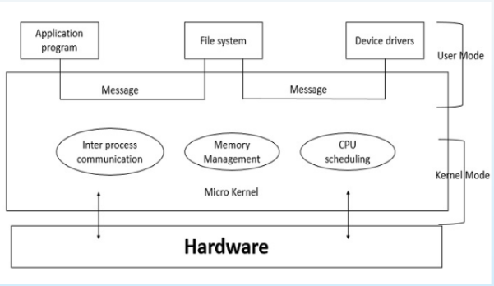

**- Only core functionalities are included in the kernel level**

**- All other functinalities moved to the system programs**

**- Communication between programs use passing message**

**adv :**

**reliable and secure**

**less overhead**

**small size**

**Dis:  
Slower execution**

**Complex communication**

System Call

A system call is a mechanism that allows a user-space program to request services from the operating system by switching from user mode to kernel mode.

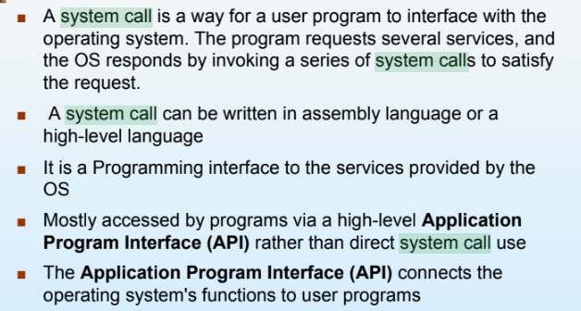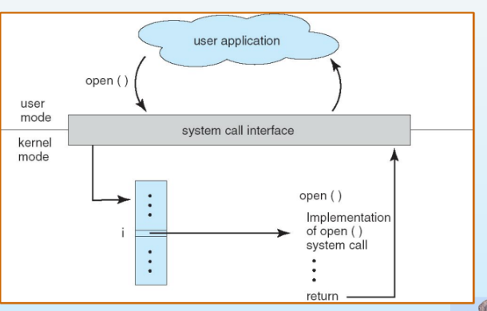

Types of system calls:

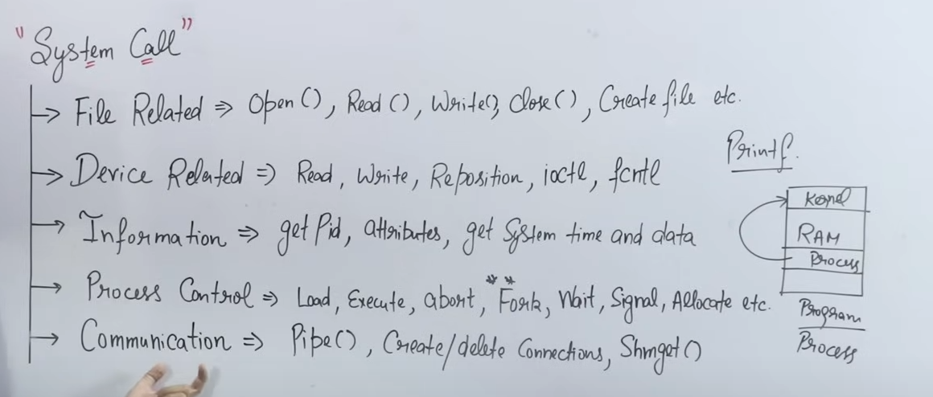

Multithreading

Multithreading is the ability of a process to execute multiple threads concurrently, sharing the same memory space, to improve efficiency and responsiveness.

Schedulers

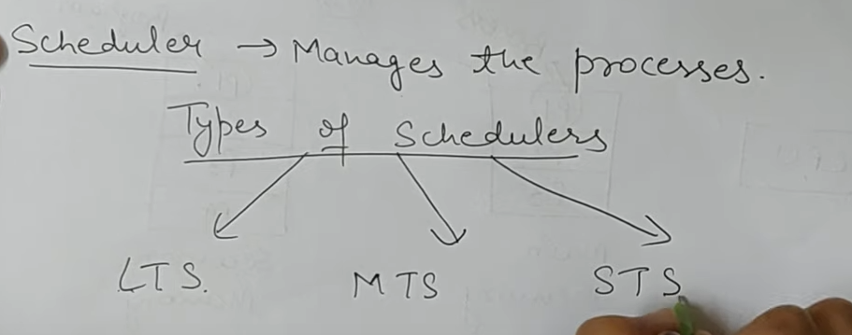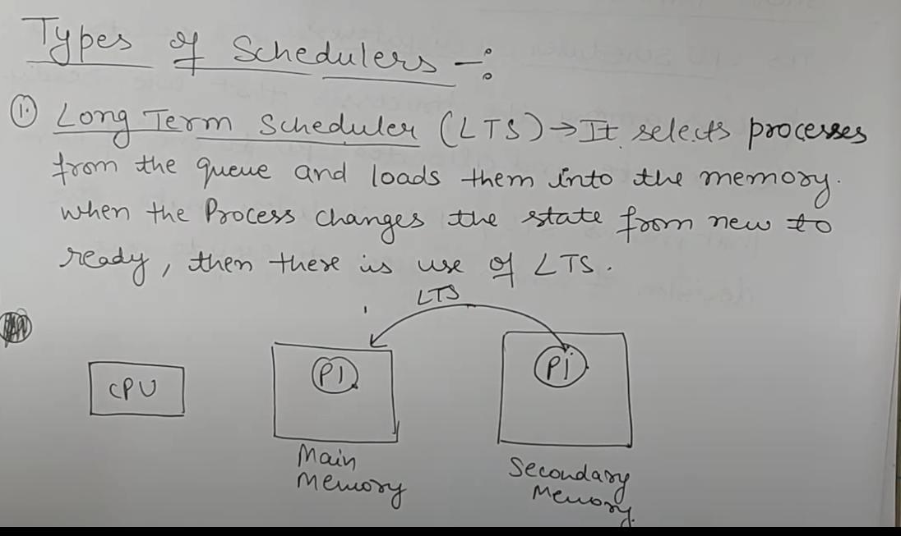

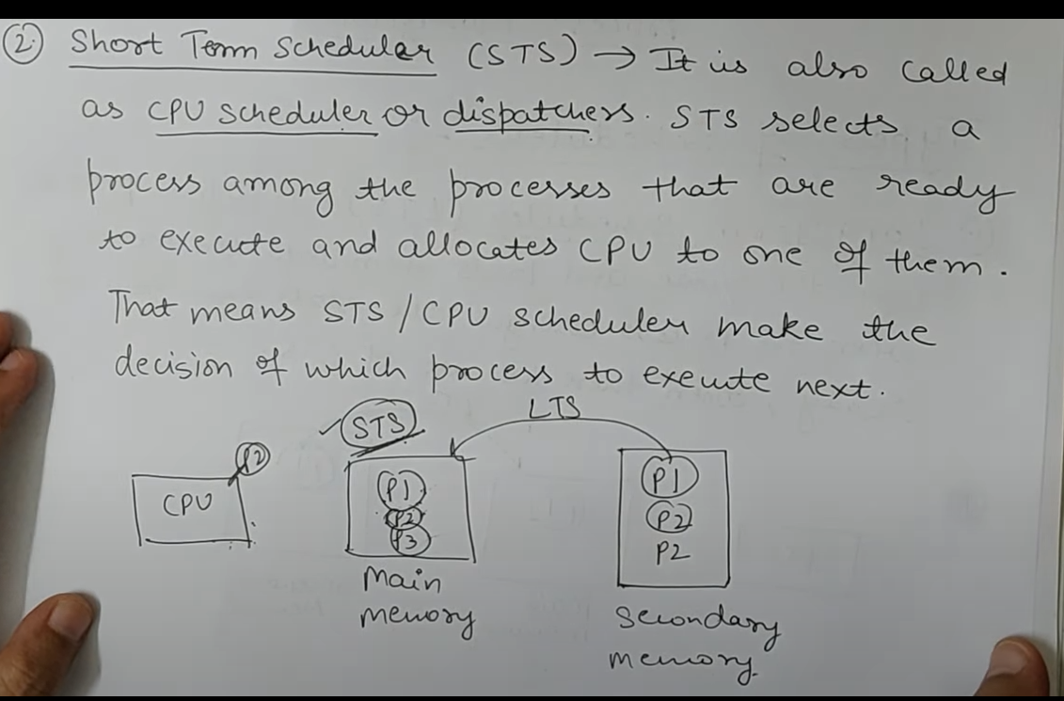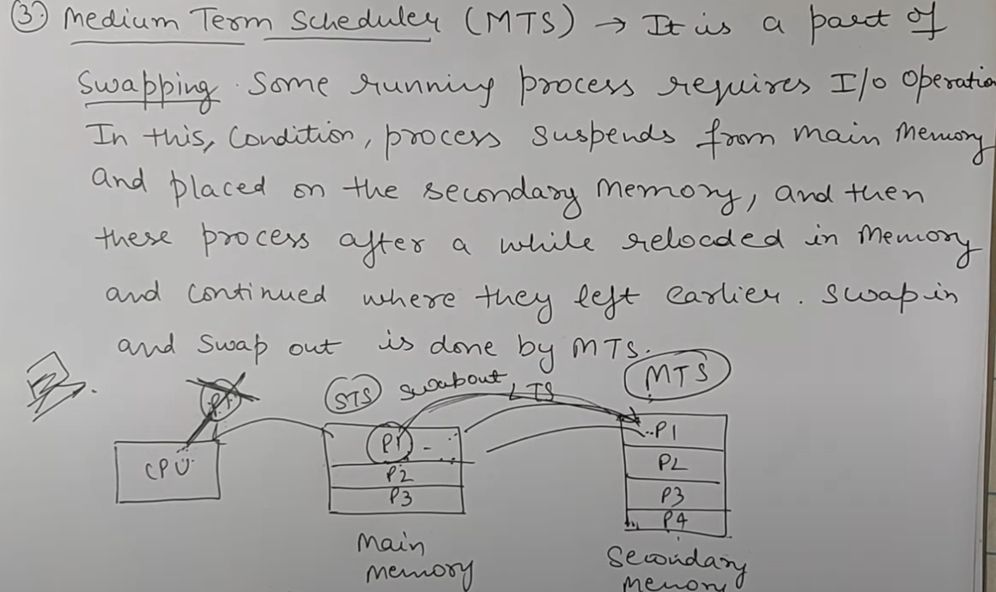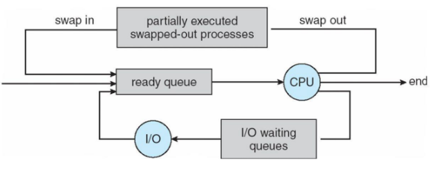

Context Switching -

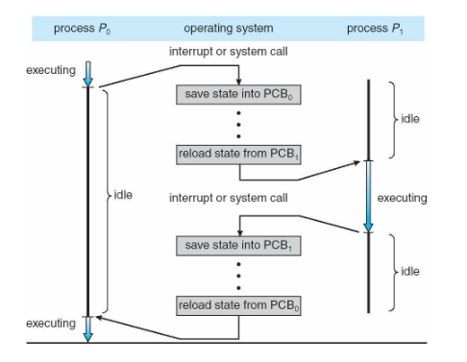

When the CPU switches from one process to another, it needs to save the current process's state and load the state of the new process. This is called a **context switch.**

The process's state is stored in a Process Control Block (PCB).

Context switching takes time, and during this time, the system isn’t doing any useful work — it's just switching between processes.

If the operating system or PCB is more complex, the switch takes longer.

The switching speed also depends on the hardware. Some CPUs have multiple sets of registers, allowing them to store multiple process states and switch faster.

**Process Scheduling**

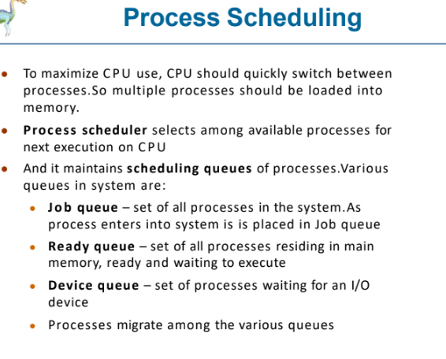

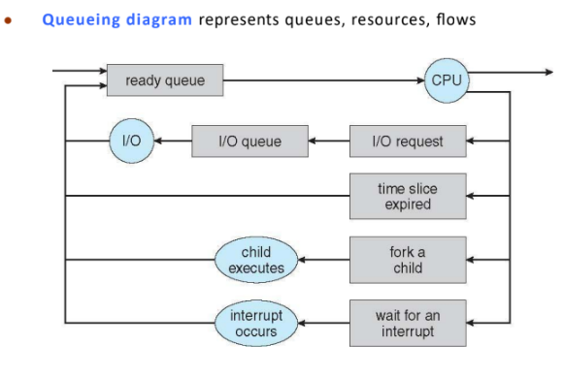

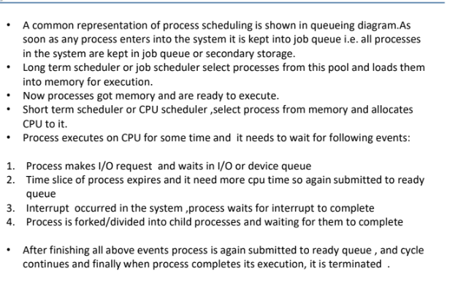

Pre-emptive vs Non Pre-emptive

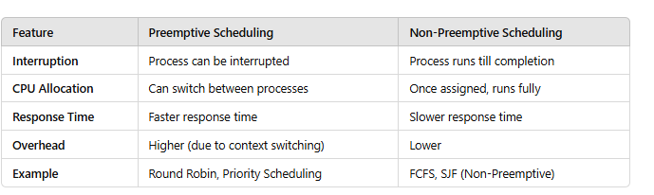

**Operations on processes**

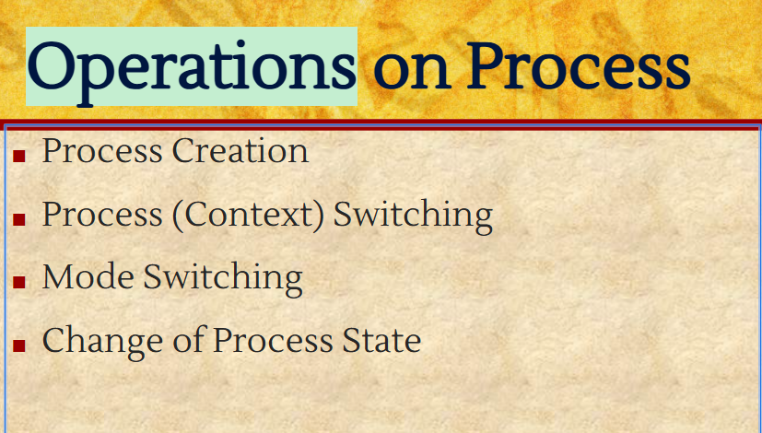

Atomic Operations:

Operations that cannot be interrupted or divided during execution. They either complete fully or do not execute at all.

**LiveLock**

**Livelock in OS occurs when two or more processes continuously change their state in response to each other but never make actual progress. It’s similar to deadlock, but instead of being stuck, processes keep running without achieving anything useful.**

**Starvation**

Starvation in OS is a problem that occurs when low-priority processes are indefinitely blocked from executing due to high-priority processes.

Principle of Concurrency

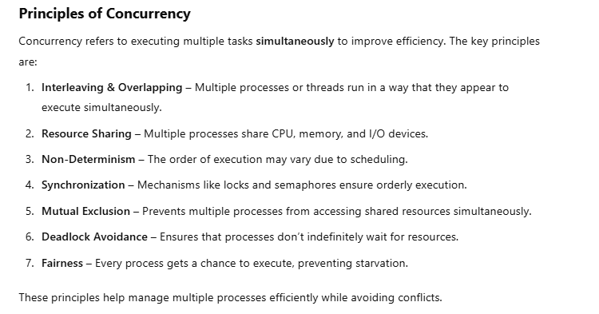

Producer